Market Research Investigation

Background and task

You have been given the challenge of forming a business that will trade successfully inside NIS at the end of the unit. By now you will already have formed your business and may even have given it a name and designed a logo. You should also have generated some ideas about possible products (goods or services) that your business could produce and sell.

Note - Your business idea MUST demonstrate BOTH concepts of added-value and sustainability.

Your task now is to investigate which of your ideas has the best chance of succeeding. You will find this out by conducting a market research investigation.

Your task is to find out if people are interested in your product and would buy it. The research question is:

Is there a market for my/our business ideas?

The investigation will be formally assessed using Criteria B - Investigating, C - Communicating & D - Thinking Critically

In order to do this effectively each business is required to produce a written report. The report should include conclusions and recommendations about how to continue with the final business idea. There is a word limit of 1500 words for the report.

You will have seven lessons to complete the task.

Stage 1 - Consider and answer the following questions;

- How does the idea demonstrate BOTH concepts of ADDED-VALUE & SUSTAINABILITY?
- Why do you need to find out if there is a market for your idea?
- What information do you need to answer the research question?
- What primary research do you plan to conduct in order to obtain the information you need? (consider: questionnaires, focus groups, interviews)
- How large will your sample need to be to obtain valid and reliable results?
- How will you select your sample so that you obtain valid and reliable results?
- What secondary sources might be of use to you?
- What difficulties might you experience when conducting your research?
- How do you plan to overcome these difficulties?

Stage 2 – Produce an action plan (400 word limit)
Use the action plan guide below to plan how you will conduct the research and present the finished report on time.

Stage 3 - Devise your research methods
Produce any questionnaires, interview questions etc that you will use to obtain the information needed to answer the research question.

Stage 4 - Conduct your research
This could be in person, by email or in another suitable way.

Stage 5 - Collate and organise the results of your research
Produce a data record sheet for your results. Use this to create charts and graphs that will show your findings clearly.

Stage 6 - Produce the written report (1500 word limit)
Use the Written Report Guide below. You should follow the recommended format.
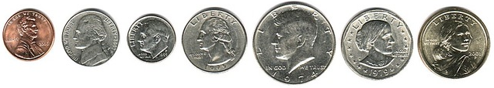

Action Plan Guide (& recommended format) – 400 word limit

a) Research question - Is there a market for {insert your business idea(s)}?

b) Rationale

1. Explain why you need to find out if there is a market for your idea(s).

c) Methodology

- What information do you need to answer the research question?
- How do you plan to obtain this information?
- What primary/secondary sources will you use?
- Justify the methods/sources you propose to use.

d) Anticipated difficulties

- What difficulties might you experience when conducting your research?
- How do you plan to overcome these difficulties?

e) Time frame

- What tasks need to be completed? How long will each task take? When do you plan to complete them? You could show this in a Gantt chart (see below) or as a table.

The final action plan should include annotations relating to any modifications that you made during the research process as evidence of you following the plan.

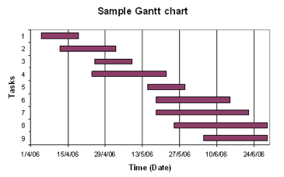

Written Report Guide (& recommended format) – 1500 word limit

Your written report should include the following;

a) Title page

b) Contents page

c) Executive summary (ES)

This should provide a clear overview of the written report. It should include the research question, methodology, main findings, conclusions and recommendations contained in the report. You should include a word count for the ES which should not exceed 200 words.

Note, this does NOT count towards the 1500 limit of your written report.

d) Introduction & research question

This is where the business is introduced, and the rationale behind the investigation is explained. It is recommended that the introduction ends with the research question.

e) Methodology

Outline what information & data you needed in order to fully address the research question, and then justify the methods used to obtain them (eg sampling method for a survey).

f) Findings and analysis

Present the results of your research. This can be in the form of charts, graphs, tables, images etc. Be sure to reference results and findings to the sources used to obtain them. You should also interpret your results. How do they affect your plans?

g) Conclusions and recommendations

You must include both conclusions and recommendations. Conclusions must draw together information contained in the report. Recommendations should be specific. Finally, identify any limitations of your report (eg reliability of sample).

h) Appendices

This section should only include information &/or data that is required in support of the text. The information/data should be referred to in the main body of the written report.

Examples of what could be included in the appendices include; transcripts of interviews, copies of questionnaires, data record sheets for primary research, copies of financial statements, news articles etc. Only include material that is referred to in the report.

Note: the 1500 word count only applies to the written text in sections d) to g). Also, all pages should be numbered, and all charts, diagrams, images etc should be titled and referenced into the text.

Remember, you will be assessed using Criteria B, C & D.

Good luck!

