The Korean War: 1950-1953

Activities

1. Class discussion

Generate questions relating to the Korean War, then conduct research to find answers.

2. Video & note-taking: How the war progressed.

Watch the CNN video about the Korean War and make notes about how the war was fought. Your notes should include; important dates, people, events, statistics and locations.

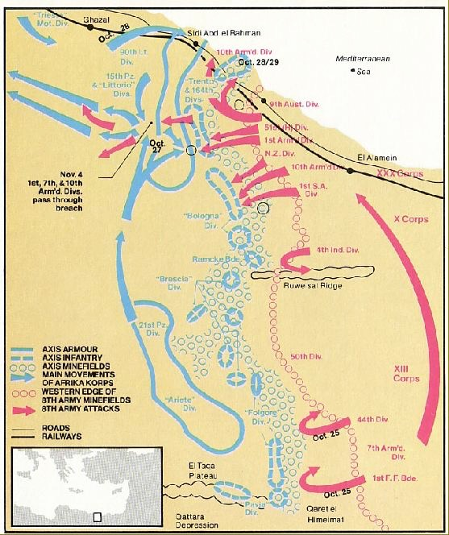
3. Mapping the progress of the war

Create an annotated (fully labelled) map showing the progression of the Korean War.
Your video notes will now be used to help demonstrate your understanding of how the war progressed through a series of annotated maps. Fig. 1 shows an annotated map from the Second World War.
You will be given a large A3 sheet containing four outline maps of the Korean peninsula – You should divide the war into four stages (one map for each stage) and annotating each map to show how the war progressed over time. You may use the notes you made in class.
Fig 1: An example of an annotated map of the Battle of El Alamein during the Second World War

You should show the following information on your map:
- North Korean army was able to take control of most of the Korean peninsula by September 1950.
2. US and South Korean forces were able counter-attack and capture Pyongyang on 19th Oct 1950.
3. Arrival of Chinese forces helped the North Koreans take back Seoul on 4th January 1951
4. Stalemate existed from July 1951 to the signing of the armistice in July 1953.

A: Geographical features
- Yalu River
- Incheon
- Seoul
- Pyongyang
- 38th Parallel
- Seas around Korea/Ocean
- Mountain ranges
- China

B: Historical Information:
- Which countries were involved and whose side they were fighting on
- The movements of the armies during the war with dates
- The final placement of the armies at the end of the war.

Terminology to be applied in a meaningful way on the map

United Nations | Invasion | Demilitarized Zone | Parallel
Containment | Armistice | Ceasefire | Proxy War
Communism | Hot War | People’s Liberation Army | Allies

4. Exam preparation

Watch the CNN episode again. This time make notes on the perspectives of different people, groups and organisations. Interpret each perspective (what does it show about how those people/groups/organisations viewed the war?) and consider the conclusions that can be drawn from them about the war.

The exam will consist of three parts;

A - will assess your use of terminology associated with the war.
B - will ask you to explain why parts of the war progressed as they did.
C - will ask you to discuss an argument associated with the war.

