G10 Assessment – Xianlin Sustainable Transport Investigation

(xuanwuhu, n.d.)

Statement of Inquiry:
Transport systems can help cities become more sustainable

Research question:
To what extent is the transport system in Xianlin sustainable?

World count:
1500 Words

Contents:
- Introduction and research question (Page 1)
- Methodology (Page 2)
- Findings and analysis (Page 3-8)
- Conclusion (Page 7)
- Evaluation (Page 9)
- Bibliography (Page 10)
- Appendix (page 11)

Cover Page

Introduction and research question
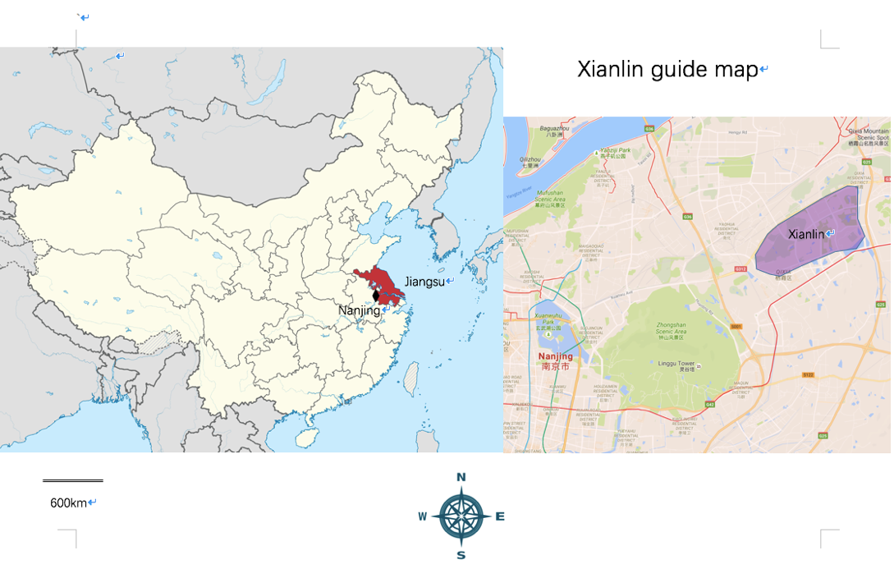
Sustainability is accomplishing the goal that our next generation can have the ability to meet their own needs. This investigation focuses on urban sustainability. Trying to achieve a long-term, viable, and self-sustaining communities in an urban setting. Limiting the degradation so it will not surpass the maximum capacity of regeneration within the system. It is taken place in Xianlin; the suburbs of Nanjing – a provincial capital of Eastern China (General location in Figure 1). Through investing how transport systems influence sustainable, work towards answering the research question:
(Figure 1: Xianlin Location maps) (TUBSBS, 2011)
To what extent is the transport system in Xianlin sustainable?
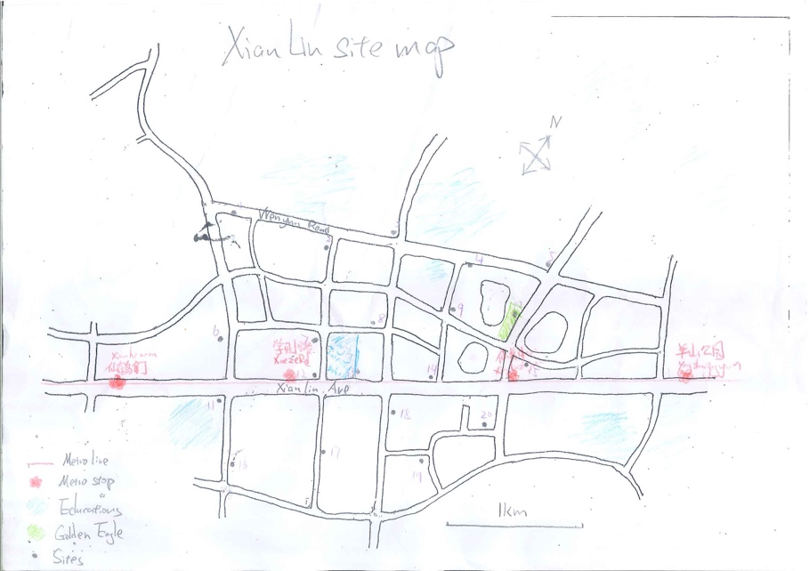
This location is known as the Xianlin University city, it was an undeveloped, rural property in 1989. As the city grew, multi-stories buildings were built, now it has become an important district of the city Nanjing (Wikipedia, 2016), shown in figure 2. During this investigation of examining and study the sustainability of the transportation system in Xianlin, knowledge of how a sustainable city model is functioned would be gained, which this process has the potential of benefiting us in the future and make the worlds a more sustainable place.
(Figure 2: Xianlin Detailed map)

Page 1

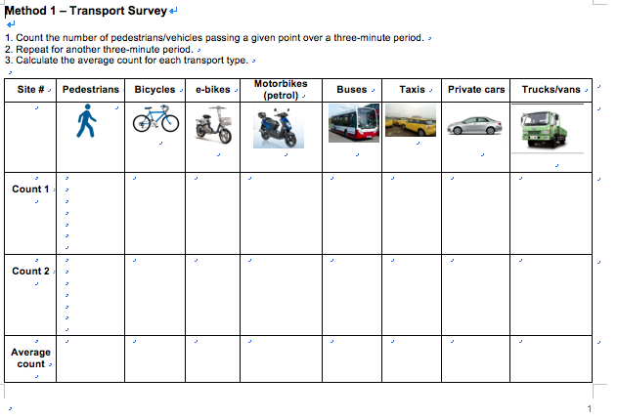
Methodology
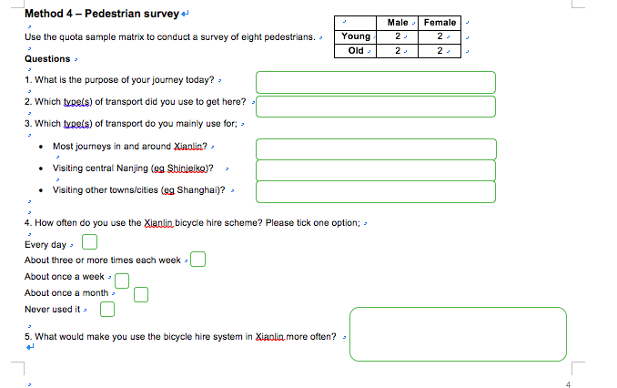
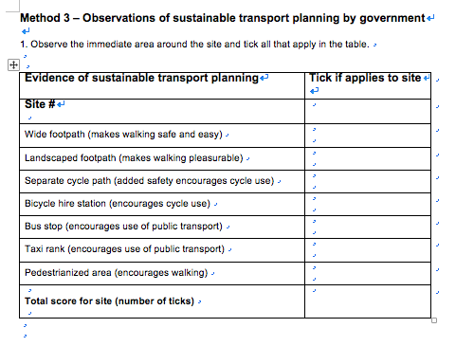
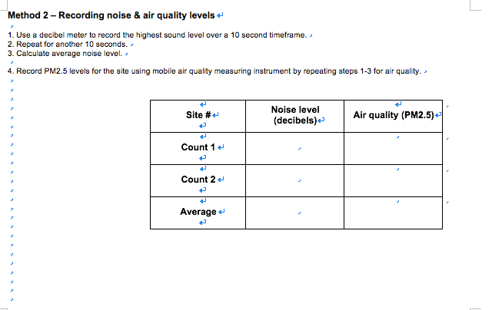
Figure 3: Transport survey
Figure 4: Noise and sound quality
Figure 5: Government Planning

As primary research, Xianlin district is equally separated into 20 blocks, within each block, a random location was generated. This process ensures there is no bias, and these location accurately represent the whole of Xianlin region. In these regions multiple tasks will be done. First task is analyzing the types of transport (Figure 3), within a given three-minute period, the number of each types of vehicle passing will be recorded. Repeat this process to ensure the validity and reliability. The second task is to collect noise & air quality reading from the selected site, it is measured by a decibel meter and an air quality monitor, averaging 2 trails and finally giving us the most reliable data (Figure 4). The third task is to observe 7 different types of sustainable transport planning; this data will directly help understand government influence urban sustainability (Figure 5). Our last task is to survey local pedestrians about their transportation method, including their transport preferences, usage of public bicycles etc. (Figure 6). The interview has to include 2 young and old women, 2 young and old men, guaranteeing the data will cover the full spectrum of age and gender groups. Secondary research was done to compare the Xianlin model to a sustainable standard.
Figure 6: pedestrian survey

Page 2
Figure 6: Pedestrian survey
Findings and analysis

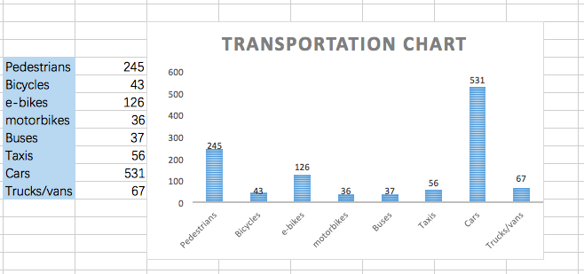
Figure 7: Bar chart of total number of different types of transportation (appendix)

The transport survey and government planning observations analyzes the phenomenon of Xianlin’s transportation status. The table (Figure 7) shows the total use of this 8 different types of transportation in the 20 selected site.
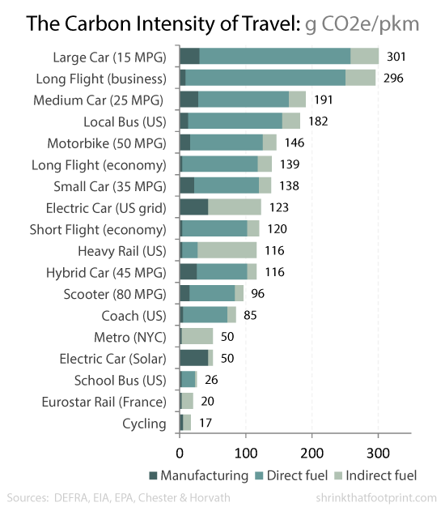

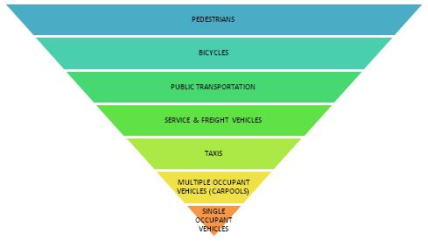

Figure 9: Ideal transportation model
(Rinkesh, 2004)

Page 3
Figure 8: Carbon Intensity of different transportation method
(Wilson, n.d.)

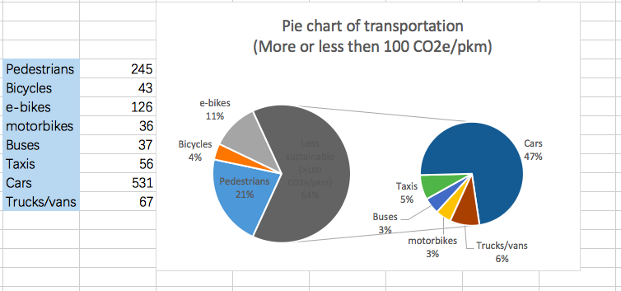
Figure 10: Pie chart that distinguishes transportation methods (appendix)

To find out in what extent is the transportation in Xianlin sustainable, the data shall be compared to a standard. Figure 8 shows the CO2 amount each type of transportation product per kilometer. Then matching it with the Xianlin model to generate Figure 10 – A pie chart demonstrating the percentage use of sustainable and non-sustainable transport. Setting the boundary of sustainability at 100 CO2e/pkm, grouping everything everything that doesn’t use renewable energy as less sustainable. A shocking 64% of the transport is powered by nonrenewable energy, producing a mass amount of CO2 that severely harms the environment, it is against the definition of sustainability. Limiting our next generation’s ability to achieve their needs. Referring to Xianlin as not so sustainable in terms of selection of transportations. Looking at Figure 9, the ideal sustainable pyramid has most pedestrians and least single occupant vehicles. Completing such sustainable environment would result a less polluted environment, better health, more sustainable economic development etc (Rinkesh, 2004).
Page 4

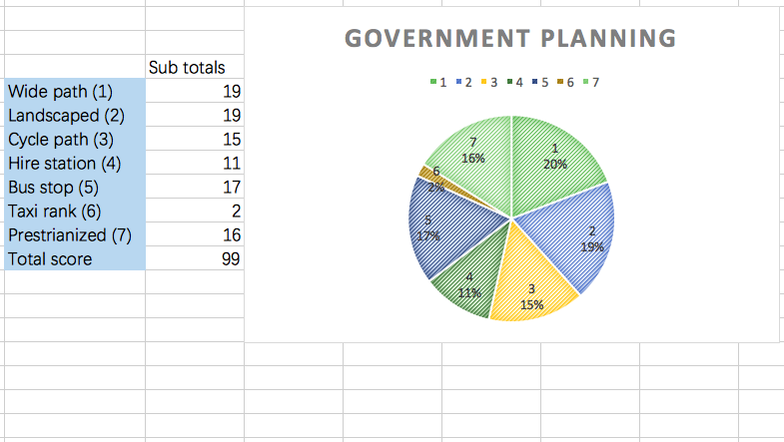

Figure 11: Pie chart of government planning (appendix)

Figure 11 shows how the government is helping improve urban sustainability by building infrastructures promoting sustainable transports. Example with Wide path built, locals would choose to walk more often. Out of 20 locations, 19 of them has built wide paths, and out of 140 total possible government planning, Xianlin has achieved an impressive 99. Showing the effort, yet from our secondary research, there are also many other methods that can help promote urban sustainability. Making existing transport model more efficient is a great way of achieving urban sustainability, light weighting and new engine and fuel technologies are making existing transportation method much more sustainable. With the alternative of hydrogen fuel cells, fossil fuel hybrid, and electric vehicles, the production of CO2 is highly reduced which will achieve a long-term, viable, and self-sustaining communities in an urban setting (Pryce, 2015).
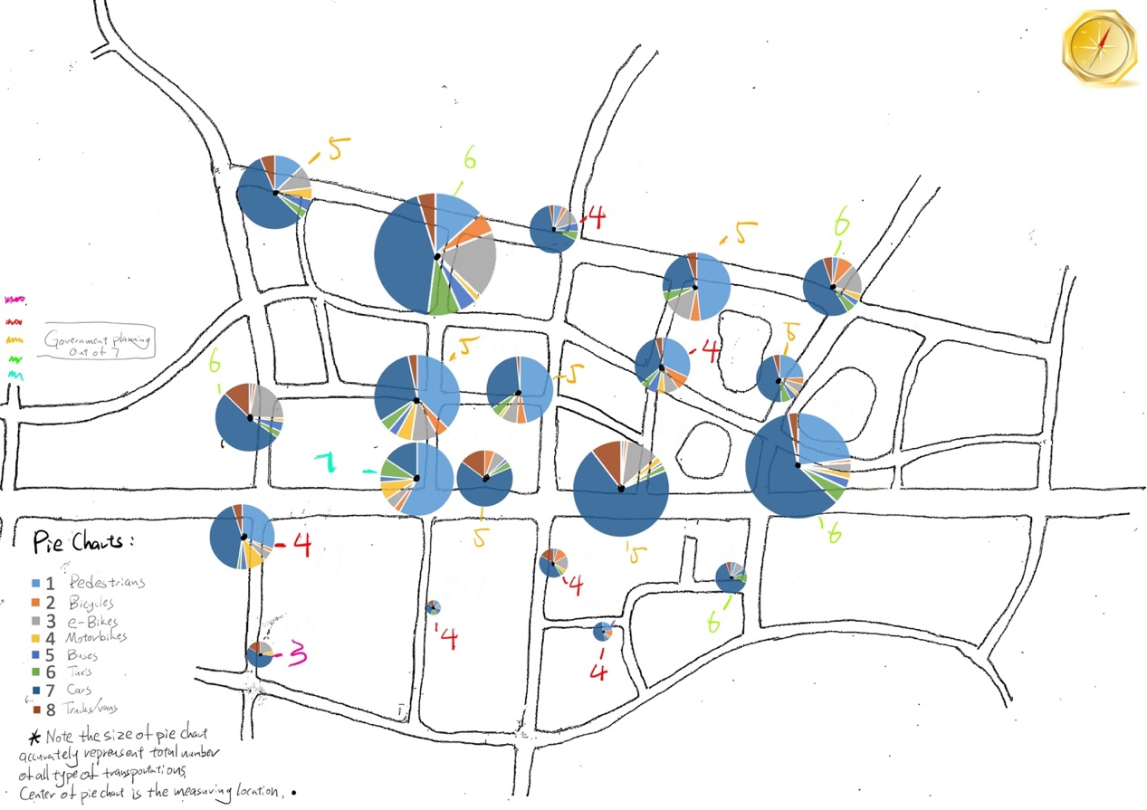

Figure 12: Map of Xianlin with transportation pie chart and government planning. (appendix)
Page 5
Figure 12 is to analyze the correlations between the occurrence of transportation and government planning on the specific locations. These pie charts represent the percentage of each type of transportation in the 20 selected spots. In the map, the center of pie chart is where the data is collected, the size of the pie shows how much the total amount of traffic there is. The colorful numbers show the amount of government planning done, the effectiveness of government planning is clearly shown. Where the most government planning is done, with all 7 types of planning, they have the most percentage of pedestrians and least percentage of cars. This is an amazing accomplishment, showing us the influence of government. Also showing the south part of Xianlin has a higher life quality.

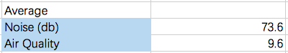

(µg/m3)

Figure 13: Chart of Xianlin average Noise & Air Quality. (appendix)

Figure 13 represents the average Noise & Air quality reading throughout data collection, comparing it with a standard world recognized model (Figure 14, 15). Arguably that Xianlin is very successful in controlling the air quality, and somewhat successful at maintaining the noise level. These arguments could be supported by an average air quality of 9.7 µg/m3, and an average noise level of 73.6 db. Appropriate tools was used to collect these data, and made sure their reliability, so according to the standard scale the air quality is in top of healthy section, and the noise quality is below an average street traffic.

Page 6
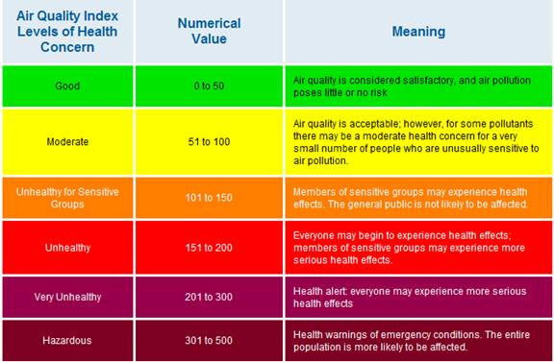
Figure 14: Air Quality standard grading. (Air Quality Index (AQI), n.d.)
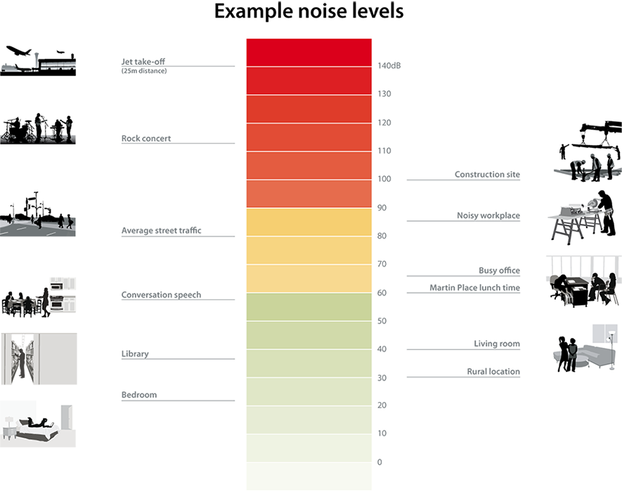
Page 6

Figure 15: Noise level standard grading (Measuring aircraft noise, n.d.)

Page 7
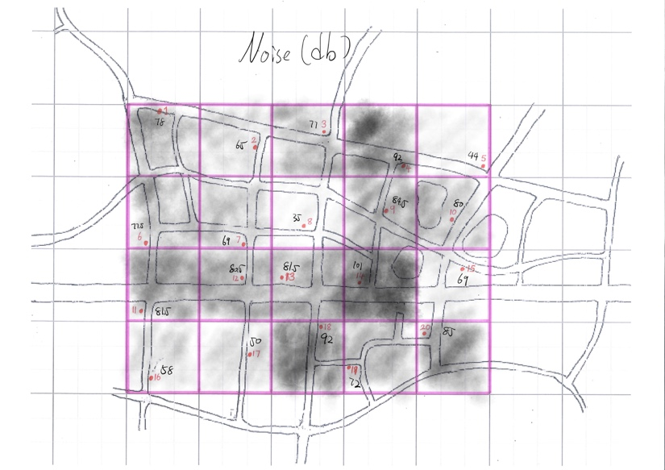
Figure 17: Air Quality site map (appendix)
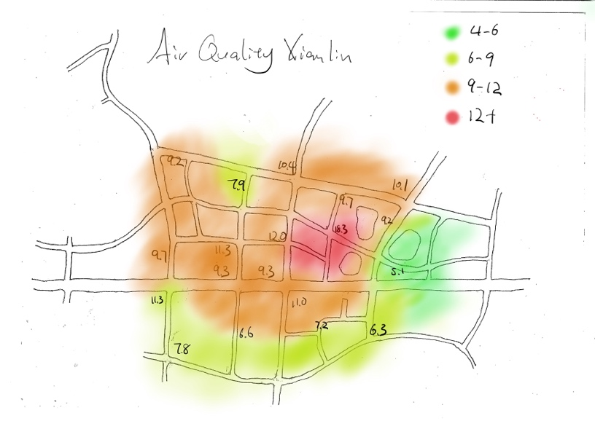
Figure 16: Noise level site map (appendix)

I have created Figure 16 and 17 to visually represent Noise and Area quality data by each location. We shall compare this result map to the Phenomenon in figure 12 map to show their relationship. Their proportional relationship is clearly shown from the noise level map, as the size of pie chart in figure 12 increases, meaning more transportations, the louder noise level also increases. Yet the air quality map has a weaker correlation, meaning there are other factors affecting air quality. These data give us a deeper understanding of how the transportations choices influence the achievement of a relatively more sustainable city.

A feedback table was collected in the appendix from interviewing the pedestrians, since there are too many variable and not identified locations, it would be inappropriate to analyze it with any form of graph. But looking straight at this data table would tell us a lot about Xianlin’s transportation choices, and help answer our research question that in what extend is transportation in Xianlin sustainable. Surprisingly compared to our first transportation survey, barely any pedestrians interviewed would use car as their main transportation method in Xianlin or to Xinjiekou. This could be caused by bias since people interviewed were mostly pedestrians walking on the streets. While most of their transportation choices were using vehicles with renewable energy or no energy consumption at all, a mass amount of people chooses to take metros since the metro system is very developed in Xianlin area. This is a very sustainable choice, transporting a great amount of passenger each time and powered by electricity, it really helps creating a sustainable urban environment. Yet the survey shows the lack of success in the public bicycle service due to many flaws the government made.
Page 8
Conclusion

After organizing the data, many valid point could be concluded about Xianlin’s transport situation. First from analyzing types of transport on the street, up to 64% of locals tend to use non-energy efficient transports, which does not match a sustainable transport model. Yet government planning is mostly taken place, making an impact on transport decisions. Second by looking at the general and areal pollution and noise level, concluding a great success of environmental control compared to a standard level. Noticing that the traffic situation is tightly related to the noise level. Finally based on an opinion survey, summarizing that majority of citizens are making sustainable choices on transportation methods, due to the awareness from government. Therefore, answering the research question, that Xianlin is relatively sustainable compare to global standard, and in some degree will maintain resources for our next generation to enjoy the same quality of life.

Evaluation

In general, this investigation was very successful and the method has lead us to a valid conclusion, accomplishing the goal for students to learn how transportation influence the sustainability of an urban area. The strength of the method is it’s detailed and clear, from the beginning it was understandable what is going happen throughout the whole process. The purpose of each step was clearly explained, and how it would help us answer the final question. The primary research was done quite efficiently, with the benefit of a well thought method, allowed us to collect reliable and valid data, comprehensively summarized Xianlin as a whole. Most of the sample sized were well set, with amount of trails gave us sufficient data to create our graphs and charts. But there are still room for improvement, our last task – pedestrian survey was not so ideal. There weren’t any pedestrians around at our location so it was very difficult to collect survey, latter on when these data were collected from other locations, many problems came up. Barely any of the locals would like to answer our questions, most would just walk away. Also when our classmates interviewed them, the different language caused misunderstandings. At the end, that data was not so useful, many results collected could not be analyzed. Apart from that, the improvements could be doing 3 trails for each task instead of 2, even 2 is enough to generate the graph, 3 trails would be more appropriate and reliable.

Page 9

Bibliography
Air Quality Index (AQI). (n.d.). Retrieved from airquality: http://airquality.deq.idaho.gov/Information_AQI.htm
Measuring aircraft noise. (n.d.). Retrieved from aircraftnoise: http://aircraftnoise.com.au/causes-of-aircraft-noise/measuring-aircraft-noise/
Pryce, T. (2015, 1 12). Sustainable transport in cities. Retrieved from Carbon trust: https://www.carbontrust.com/news/2015/01/sustainable-transport-cities
Rinkesh. (2004). What is Green Transportation? Retrieved from conserve-energy-future: http://www.conserve-energy-future.com/modes-and-benefits-of-green-transportation.php
TUBSBS. (2011, 9 15). Jiangsu in China. Retrieved from Wikipedia: https://en.wikipedia.org/wiki/File:Jiangsu_in_China_(%2Ball_claims_hatched).svg
Wikipedia. (2016, 8 20). Xianlin University City. Retrieved from Wikipedia: https://en.wikipedia.org/wiki/Xianlin_University_City
Wilson, L. (n.d.). 5 Elements of Sustainable Transport . Retrieved from shrinkthatfootprint: http://shrinkthatfootprint.com/5-elements-of-sustainable-transport
xuanwuhu. (n.d.). Retrieved from Nanjing Travel: http://en.nju.gov.cn/

Page 10
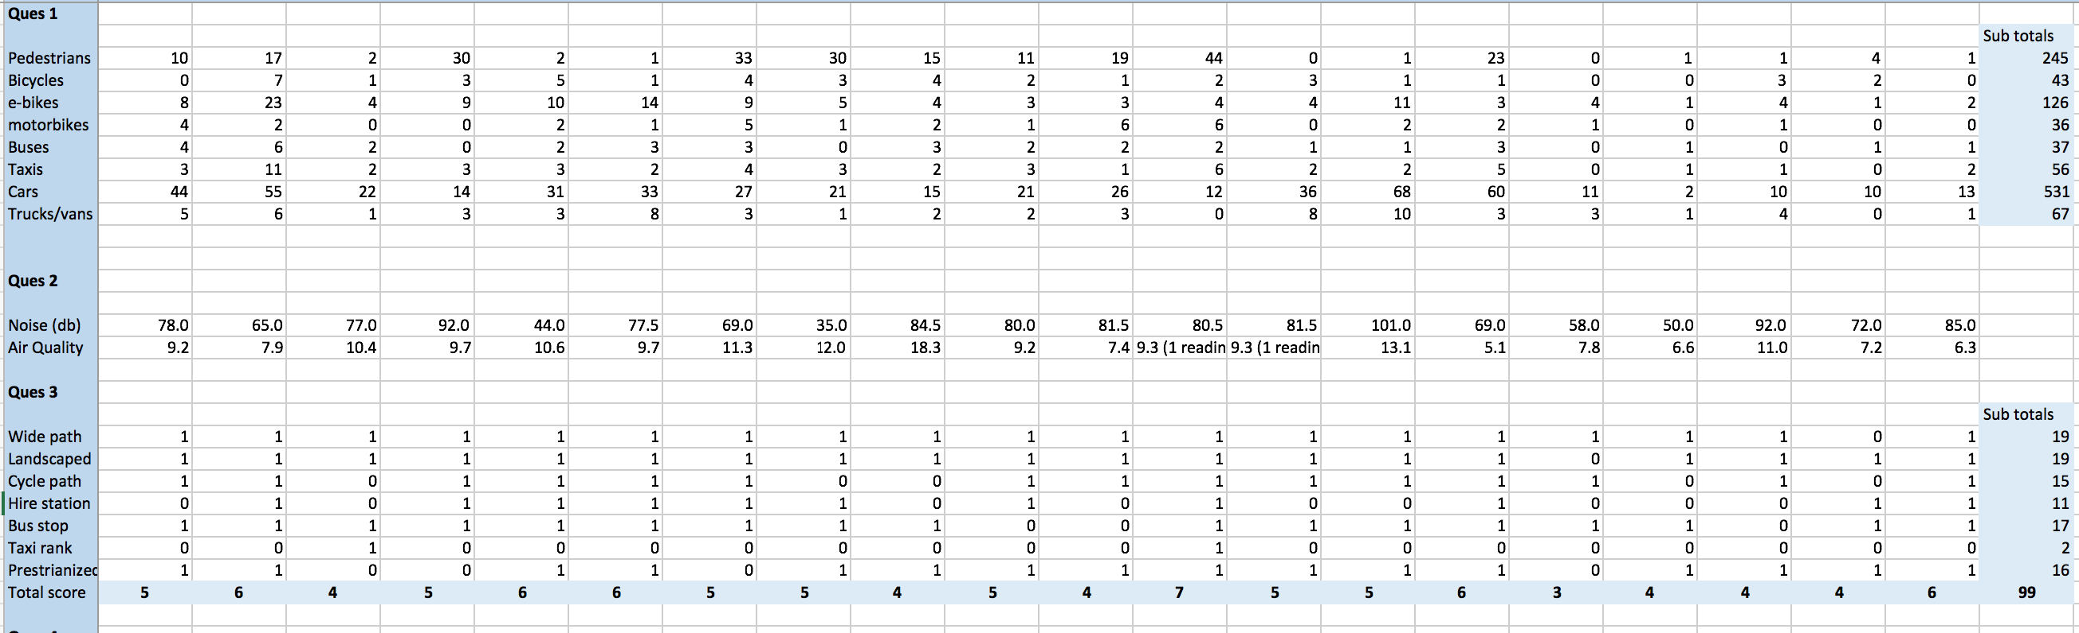
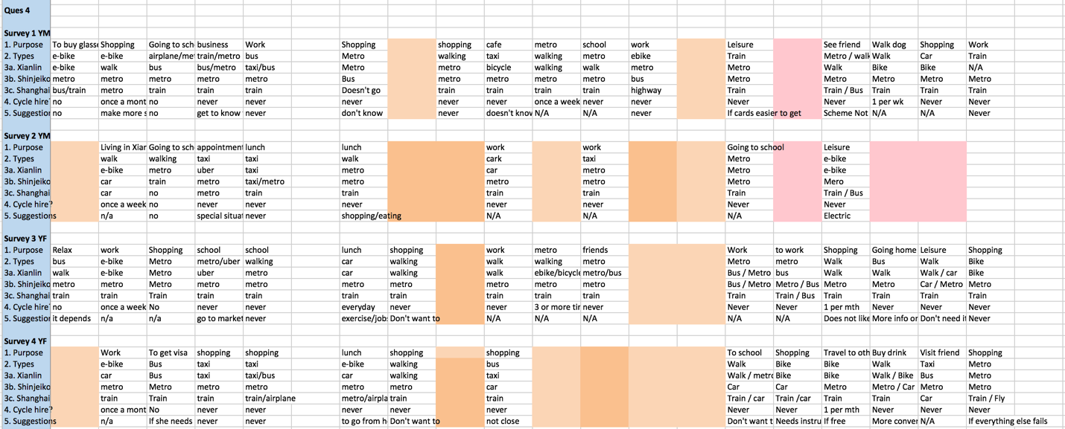
Appendix
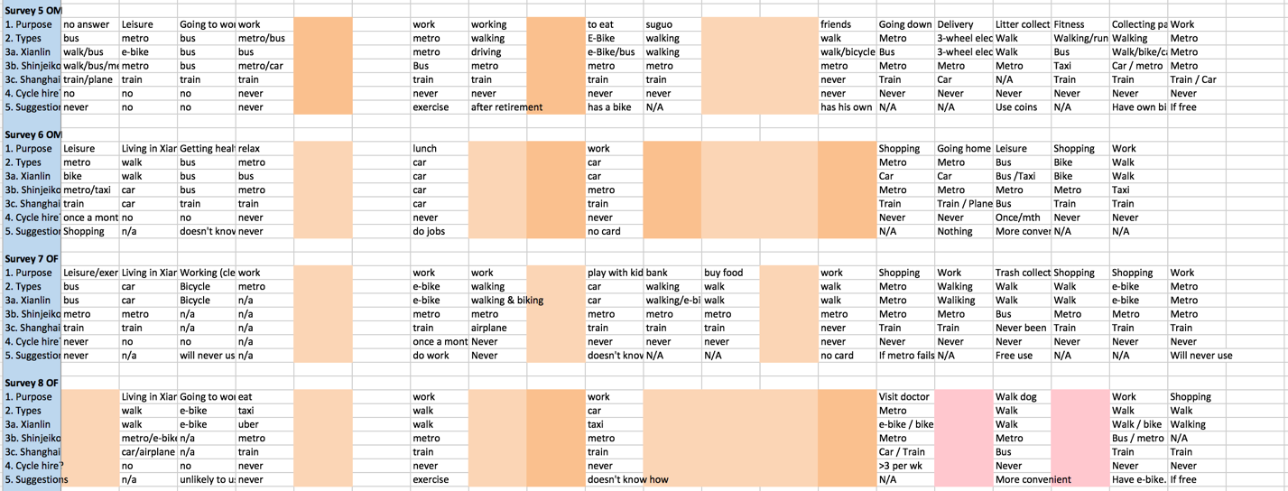
Raw data
Page 11

