MYP Humanities

G10 Assessment – Xianlin Sustainable Transport Investigation

Name:

Criterion B | Investigating | Maximum 8
Criterion C | Communicating | Maximum 8
Criterion D | Thinking critically | Maximum 8
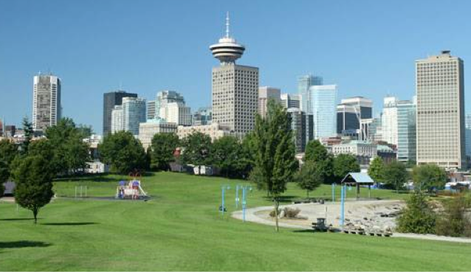

Statement of Inquiry:

Transport systems can help cities become more sustainable.

- Investigate the above statement of inquiry by conducting research into the following research question:
To what extent is the transport system in Xianlin sustainable?
- The final product will be an individual written report of no more than 1500 words that addresses the research question.
Time frame

You have around eight classroom lessons following the primary data collection in Xianlin, plus out of lesson time in which to follow the action plan, conduct secondary research and write your report. Submission date is Friday September 15th.

Tasks

1. Introducing the Action Plan for the investigation.

- The action plan shows how and when you should carry out different parts of your investigation to meet your deadline.
- The action plan is your primary planning document. It is intended to guide you through your research and towards your written report.
- Use the template found below. It is a working document that may be amended (changed) as you work through your investigation. You will need to consider what needs to be done before and after the primary data collection.

Action Plan Template

Date & time | Planned activities | Action
17th August | Meeting of G10 classes to introduce the Xianlin sustainable transport investigation.
17th – 28th August | Produce a complete and fully labelled map of the Xianlin study area. You will be given a blank outline map to complete.
17th – 28th August | Conduct secondary research (eg use of appropriate websites & library resources) into the sustainability of different forms of transport found in urban places.
17th – 28th August | Conduct secondary research into sustainable transport strategies used in urban areas around the world. How do they operate? Have they been a success? Could they be used in Xianlin?
17th – 28th August | Prepare for data collection. Students need to be paired. Decibel app needs downloading. Sites need allocating to pairs. Review how to collect data at the site.
29th August | Data collection in Xianlin - All three classes.
30th August | Consolidation of raw data into a single document. This is given to all students via shared Microsoft 365 document.
31st Aug – 15th Sep | Write introduction and methodology
31st Aug – 15th Sep | Process data by creating appropriate charts/diagrams/maps that help to turn the raw data into useful information.
31st Aug – 15th Sep | Write your analysis of your findings. Does the data support the view that Xianlin has a sustainable transport system or not? What is the evidence? You should incorporate both primary and secondary research findings here.
31st Aug – 15th Sep | Conclusion – Overall, what have you found out about Xianlin’s transport system? Make sure you answer the research question!
31st Aug – 15th Sep | Evaluation - How effective was the data collection that you did? Could it have been done better? How?
Friday 15th September | Submission of written report. Make sure you create an appropriate front page for your report. Include the actual word count on the front cover. A contents page should be included, and all pages should be numbered. You MUST follow the required format (see below).  All charts, maps & photos should be referenced in the text. All secondary sources should be referenced using APA.  The raw data sheet should be included at the back in an appendix.

2. Conducting the primary research

- On Tuesday August 29^{th,} all the G10 Humanities students will collect primary data for the investigation. You and a partner will collect data from one site in Xianlin using a data record sheet. You will conduct a transport survey, record noise and air quality, make observations of government planning, & conduct a short survey of pedestrians.
- Your site will be given to you by your teacher. About 20 sites will be used in total. They will be selected using a stratified random sample to ensure an unbiased coverage of the central Xianlin area.

3. Conducting secondary research

- You should collect information relevant to the investigation from secondary sources like government reports or news articles to support your primary research data. For example, you could find out how sustainable different transport types are. It is important that you record both your findings and sources since you will need to justify any arguments you make in your written report.

- Make sure you reference any external sources using APA.

3. Producing a written report that answers your research question.

You will present your research findings as a written report that follows a logical sequence.

Your report should have a title page and a contents page, and must follow the format below: Assessed in C (ii)

- Introduction and research question (suggested word limit – 200)

This section will include:

- a definition of urban sustainability. Assessed in D (i)
- a description of the location of your study area. Assessed in C (i)
- a fully labelled location map. Assessed in C (i)
- the research question and the aim of the investigation. Assessed in C (i)
- a rationale (reason) for doing the investigation. Assessed in C (i)

- Methodology (suggested word limit – 200) Assessed in B (iii)

This section should include:

- What data/information was needed to answer the research question.
- the methods actually used to collect the data/information – provide details of how data was collected and include reference to any secondary sources used.
- A justification for the methods used (ie explain why the methods provide data that is both valid (correct) and reliable (easily corroborated ie similar results are likely if methods were repeated).

- Findings and analysis (suggested word limit – 800)

This section will:

- present your findings using suitable visuals (charts, illustrations, maps, statistics). Assessed in C (i)
- reference visual material to the main body of text. Assessed in C (iii)
- describe your findings both primary and secondary (if used) and explain how they relate to the research question. Assessed in C (i)
- include a discussion of the concept of sustainability and how it applies to the investigation. Assessed in D (i)
- Include valid, well-supported arguments that relate directly to the research question. Assessed in D (ii)

It may be a good idea to divide your findings into sections with sub-headings to keep your report clearly focused and organized. Your analysis should be focused on the research question.

- Conclusion (suggested word limit – 100) Assessed in C (i)

You need to:
- Summarize your main findings.
- Use these findings to answer the research question.

- Evaluation (suggested word limit – 200)

- Use this section to identify the strengths and weaknesses of the methods and sources that you used throughout the research assignment. For example, you could discuss the implications of sample size. Assessed in B (iv)

- Reference list and in-text citations Assessed in C (iii)

- All secondary sources must be referenced using APA format. Charts, tables and graphs should be referenced to raw data record sheets in an appendix. Your report must be word processed using Word. Note that referencing/citations do not count in the final word limit of 1500 words.

Assessment Criteria
You will be assessed on three IBMYP Humanities criteria;

- Criterion B: Investigating
- Criterion C: Communicating
- Criterion D: Thinking critically

