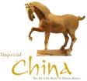

Was Imperial China a great civilization?

Categories | Evidence
Laws
Leisure
Comfort
Peace
Education
Other evidence?

From the evidence provided write a paragraph stating whether you think Imperial China was a great civilization. Be sure to use examples to highlight your answer.

