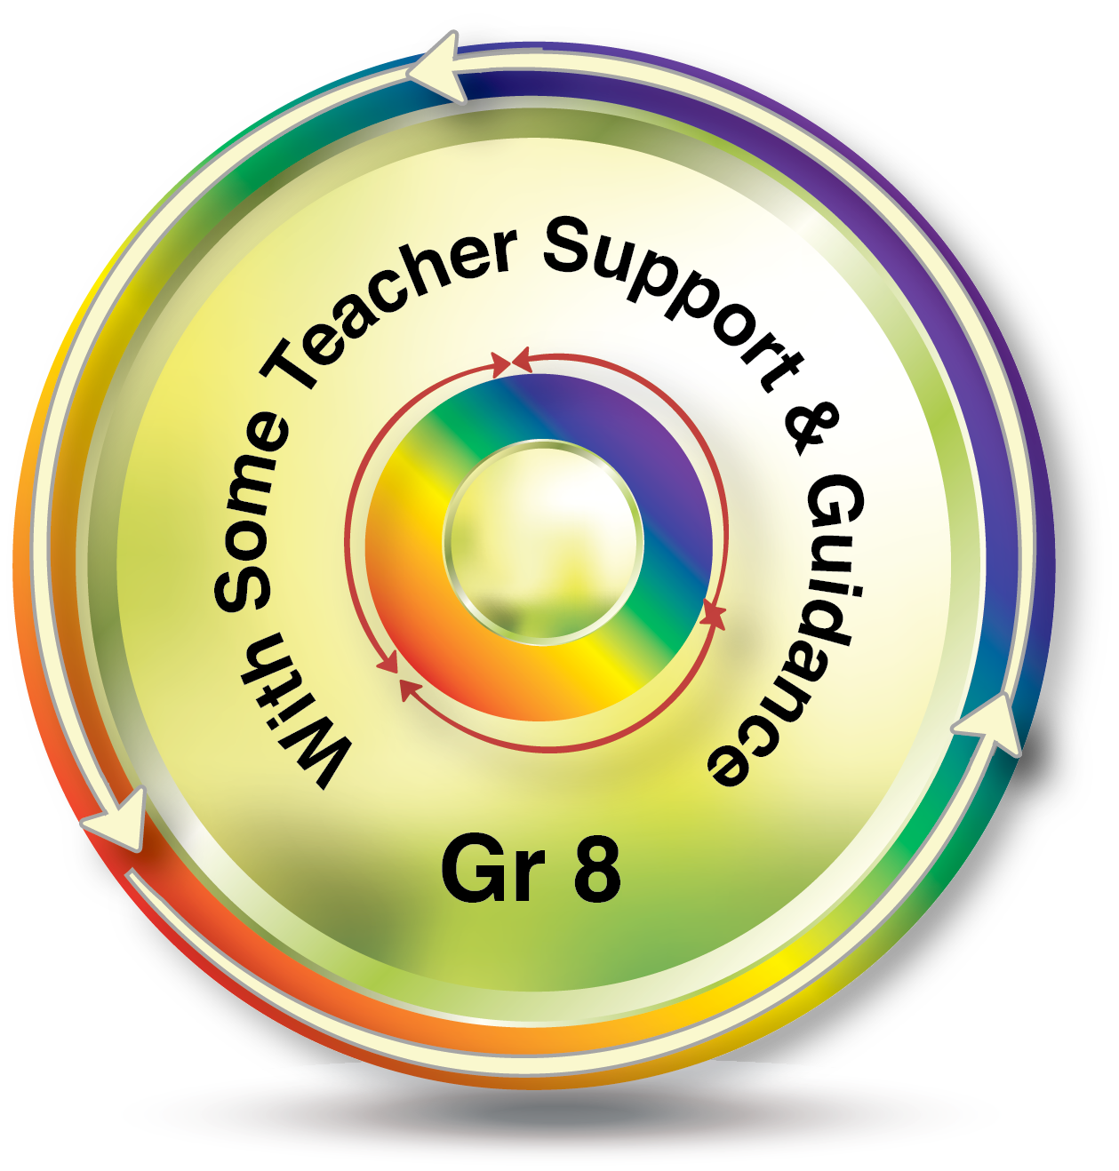

**Collaboration**

* listen actively to other perspectives and ideas
* Encourage others to contribute

**Subject: Humanities Grade: 8**

**Social Skills**

**Self-Management Skills**

**Information Literacy**:

* Make connections between various sources of information
* Identify primary and secondary sources

**Communication**

* Use a variety of formats for sharing and presenting your learning

**NIS Transdisciplinary Skills: Approaches to Learning**

**Organization**

* Bring necessary supplies to class
* Keep an organized and logical system of information/files/notebook

**Research Skills**

**Transfer**

* Gather and organize relevant information to formulate an idea or argument
* Revise understanding based on new information

**Thinking Skills**

**Communication Skills**