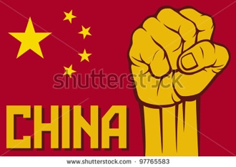
Grade 8 unit 2:

qi pao style

China 1900 -1938
KEY CONCEPT: CHANGE
RELATED CONCEPTS: CAUSALITY & IDENTITY
SOI: The actions of few can CAUSE a CHANGE in social IDENTITY.
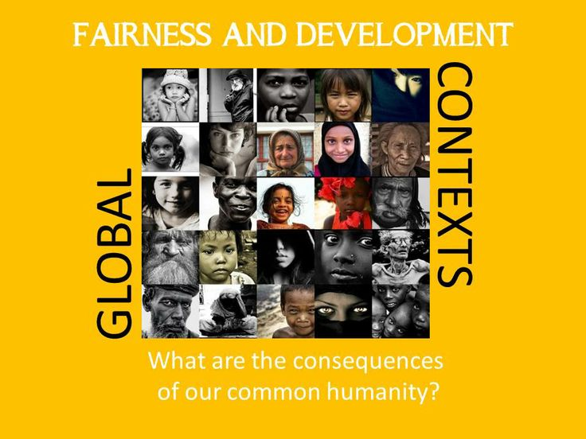
GLOBAL CONTEXT:
What are the consequences
of our
common humanity?

