Ting Ting
Deaf School
Bake Sale

Friday, October 30th
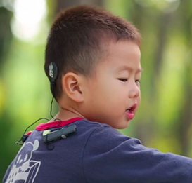
Breaktime
Lunchtime
Foyer

Cookies
Korean food

Bring change.

All proceeds go to buy hearing aids to
Ting Ting Deaf School students.

