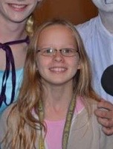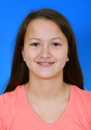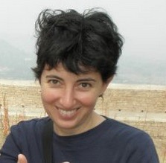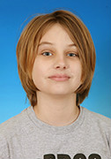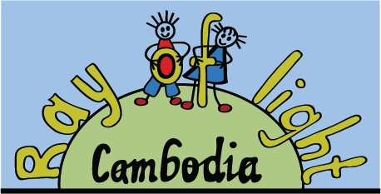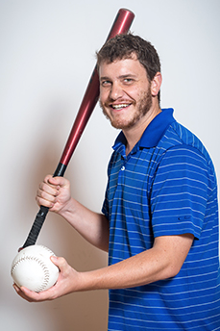

Sophie Runte

10 rmb

Rick Fischl

70 rmb

Felicity Crook

95 rmb

Rebecca Creme

127rmb

Noah Smith

332 rmb

**A great start. We now have 5 ‘volunteers’. Come along and put money in the tub of the person you want getting a crazy haircut.**

**We will collect for two weeks and the haircut will happen on Friday 29th April.**

**For every 5rmb you donate you get one vote. All proceeds go to Ray of Light Cambodia**