Pfrang Giving Tree

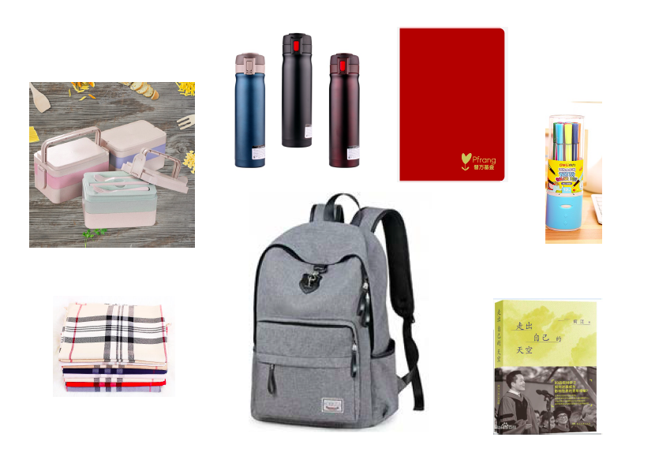
This year, with kind donations from the NIS community and Alipay, we are able to give the 321 Pfrang students the following items, and more:
Gift tags are on sale in Primary School classrooms
(prize for the class that buys the most!),
at the Winter Concert and at the RFG Christmas Market.

Alternatively, email kathadams@nanjing-school.com or come to C146.

Every tag purchased gives you a chance in the raffle!

Thank you for your continued support.

