Political beliefs questionnaire
Complete the questionnaire below. You must tick the statement that most fits your beliefs:
- When it comes to change...
- I welcome it with open arms! | - I am cautious about it, but will accept it if there is a strong need!

- When it comes to society as a whole...
- I am not happy with the inequality within it. I wish that more measures could be taken to improve equality. | - I think that inequality is inevitable (bound to happen). Some people work harder than others to gain wealth.

- When it comes to government and society...
- I think that the government should play an active role in improving people’s lives. | - I think the government should not interfere with people’s lives.

- When it comes to society and wealth...
- I think that wealth in society should be equally distributed. Poverty is an issue and could improved this way. | - I think that those who are more wealthy should keep it! They earned it after all.

- When it comes to tax and government spending...
- I think that there should be higher levels of tax (with more coming from the rich) to pay for improvements to society, such as health, education and crime. | - I think that taxes should be lower so that people have more money to spend and to encourage business.
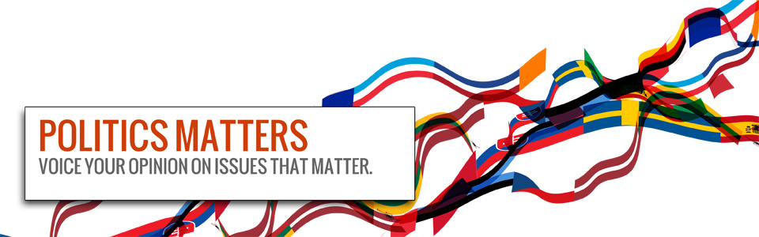
- When it comes to the economy...
- I think that the government should closely monitor it and regulate it. E.g. close control of the banks. | - I think that the government should let it be free from government interference.
- When it comes to public services (services run by the government for the public)...
- I think that they should remain in government hands. It is important that the government runs institutions such as the NHS. | - I think that too many services are run by the government. More of them should be privatised to save money for the government.
- When it comes to law and order...
- I think that to reduce crime the government must solve the underlying causes of crime such as poverty. | - I think that the only way to reduce crime is to be tough on criminals. Prison sentences are the only deterrent.
- When it comes to international affairs...
- I think that the government should take an internationalist approach. Global influences affect our politics; therefore we must be open to other countries. | - I think that national interests come first and that all else should come second. Still be open to other countries, but make our own issues a priority.
- My favourite colour is...
- RED | - BLUE
I HAVE SCORED /10 FOR (A) I HAVE SCORED /10 FOR (B)

