IB MYP GRADE 7
Key Concept: CHANGE
Related Concept: POWER, CULTURE & IDENTITY
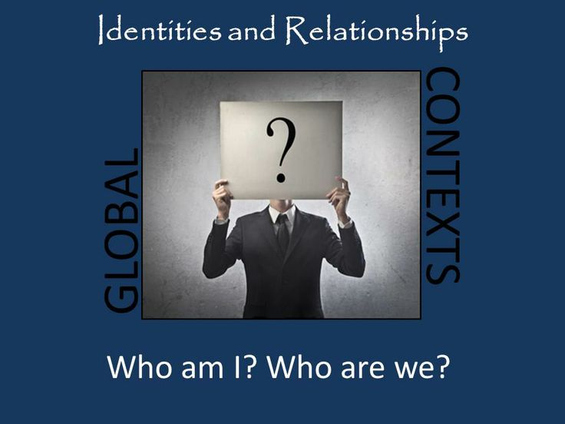
Statement of Inquiry: POWER can be used by one civilization to CHANGE the CULTURE and IDENTITY of another.

