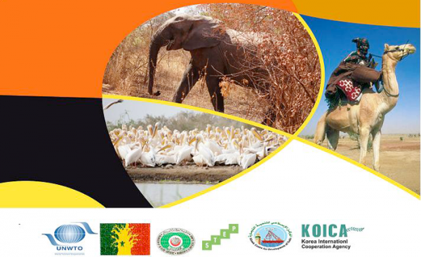
Grade 7
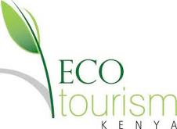
Sustainable Tourism Website 2016
Responsible INTERACTIONS with people and places involve making SUSTAINABLE CHOICES

Summer vacation is fast approaching and people have begun to plan their holidays.

You and your team have a trip to sell and a website to publish!

Where will you take people? How much will it cost? How sustainable will your holiday be? How will you use the Traveler’s Code?

You are going to make a website advertising your holiday and giving people all the information they require in order to make a choice about which holiday they will choose.

Step 1: Research:

Research, research, research, that is the key! You will need to look at travel and travel agency websites to help with your research. Also you might want to look at travel guidebooks. Websites that might be helpful include:

Travel websites | Travel websites | Travel websites
http://www.intrepidtravel.com/ | http://www.gapadventures.com/ | http://www.eyesonafrica.net/
http://ww1.flysaa.com/ | http://www.emirates.com/ | http://www.tourvacationstogo.com/
http://www.expedia.com/ | http://www.quotewright.com/ | http://www.travelocity.com/resolve/default

Step 2: Create an Itinerary:
Your itinerary (travel plan/look this word up) must include:

- A 7-night holiday schedule beginning and ending in Nanjing
- Up to three different places that you will visit in that country
- What you will do and see each day?
- How you will travel between the places?
- Where you will stay each night?
- A world map of the route that you will take including the places that you will visit

Step 3: Work out the cost of the entire trip:
- You will have to determine how much the trip will cost the passengers. This will be difficult and will involve some research, especially if you are going on safari and there are no hotels that have a price. You will have to use other trips from the websites to get an idea of what the trip will cost.
- Remember to include:
- cost of travel (flights, buses/trains etc between destinations)
- cost of accommodation
- entry tickets to attractions
- food (breakfast, lunch and dinner)
- cost of people that are needed e.g. drivers/guides
3. Your cost per person for the trip should not exceed 35000 RMB.

Step 4: Facts about the country/countries that you will visit:
You should write some information about the country or countries that you are going to visit. Things that you may include are history of the country, geography, culture, people. Use the Lonely Planet website and guidebooks to help you with this.

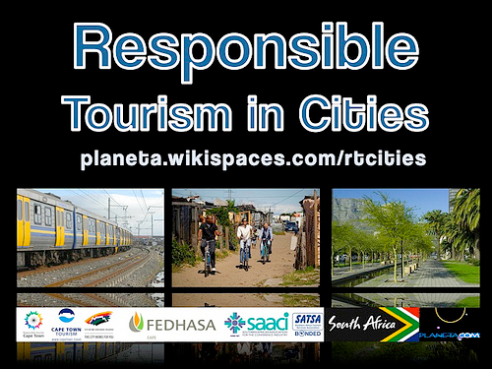
Step 5: Responsible Tourism:
You need to incorporate the work we have done on the Traveler’s Code into your assignment. Explain how your trip is going to be sustainable/eco-friendly and give advice to people of how they should behave when on your trip. The Intrepid website has a section on this as well http://www.intrepidtravel.com/

Step 6: Extras (your choice for extension):
Other things you need to think about: Travel/medical insurance, visas, language (you might want to create a basic phrase sheet for your customers). You will also need to think about advertising your trip, creating a company name and logo. Will you produce a downloadable brochure?

You will be assessed on MYP Humanities criterion:
B (action plan and reflection) and C (communicating information using a website).

