Ancient Civilisation Project: Farming

Your Objectives…

- To investigate an ancient society of your choice, one that flourished at some point between 10000BCE and 2500BCE
- To research one of the three following aspects of ancient societies as they apply to your chosen civilisation: farming, trade, ideas/beliefs
- To present your findings in a way that seems best to you (in terms of clarity, depth of detail, and engagement for the audience)
- You will have 3 to 5 minutes to present your findings.

Farming

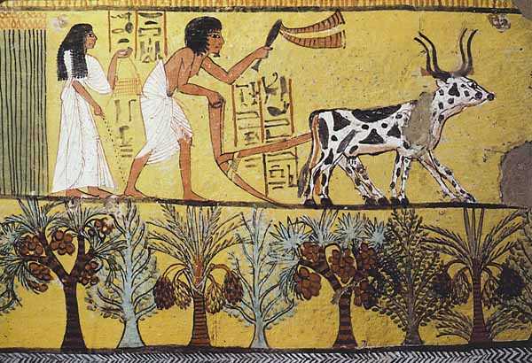
You need to explore why the shift from hunting and foraging to cultivation (and the domestication of animals) led to the development of permanent settlements and changed relationships to the environment

Ask yourself these questions about how farming impacted the society you have chosen.

- Why did humans shift from hunting and foraging to cultivation?
- What were the main farming methods?
- What were the main crops grown?
- Were the main crops just food, or were crops used for anything else?
- How did both of the above help the society to develop and grow?

Your presentation will be done as a group. Choose your partners carefully!

Your presentation will be a group grade using Criteria A, C and D.

