Ancient Civilisation Project: Ideas/beliefs

Your Objectives…

- To investigate an ancient society of your choice, one that flourished at some point between 10000BCE and 100CE
- To research into one of the three following aspects of ancient societies as they apply to your chosen civilisation: farming, trade, ideas
- To present your findings in a way that seems best to you (in terms of clarity, depth of detail, and engagement for the audience)
- You will have 3 to 5 minutes to present your findings.

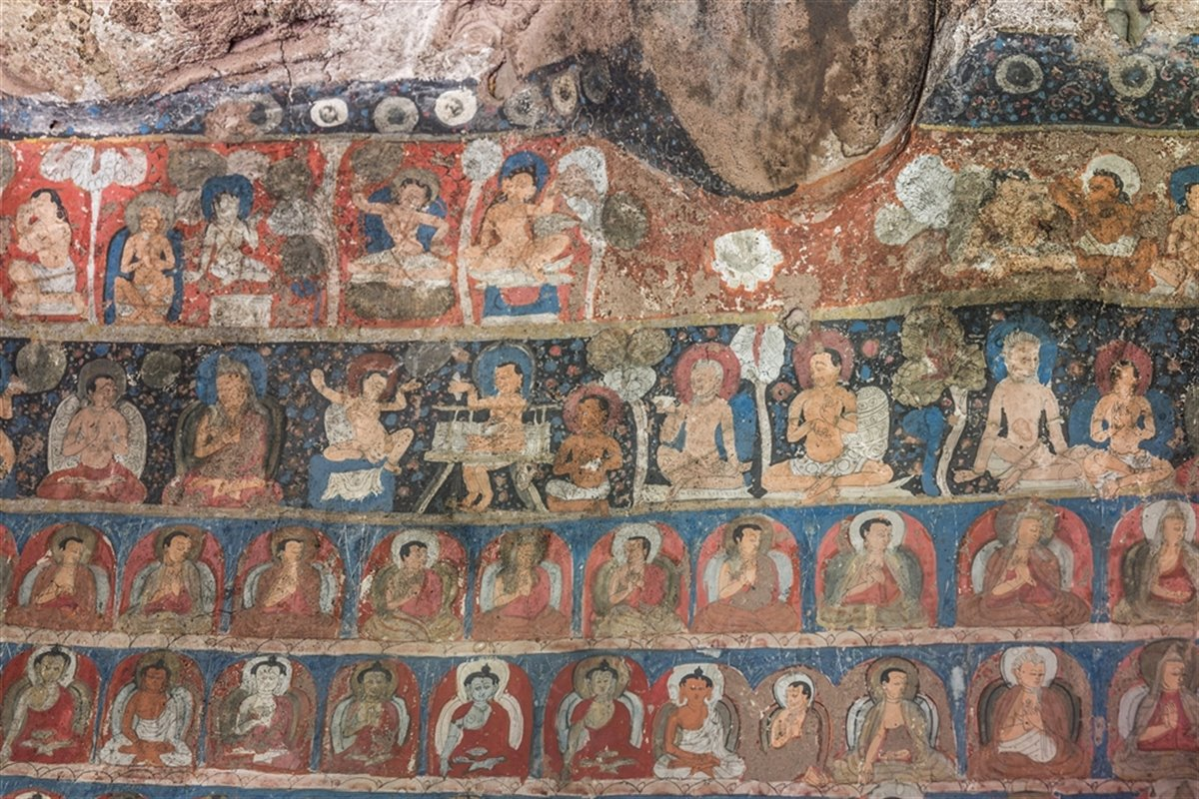
Ideas

You need to identify the major religions/philosophies that emerged by the end of the period (Hinduism, Judaism, Buddhism, Confucianism, Christianity, Islam) and their key beliefs (through group work)

Ask yourself these questions about how ideas impacted the society you have chosen.

- Explain the ideas you are going to focus on (religious or philosophical).
- Who were the main historical figures who introduced these ideas?
- How did these ideas affect the society?
- Did these ideas spread outside to surrounding cultures and societies?

Your presentation will be done as a group. Choose your partners carefully!

Your presentation will be a group grade using Criteria A, C and D.

