Ancient Civilisation Project: Trade

Your Objectives…

- To investigate an ancient society of your choice, one that flourished at some point between 10000BCE and 100CE
- To research into one of the three following aspects of ancient societies as they apply to your chosen society: farming, trade, ideas
- To present your findings in a way that seems best to you (in terms of clarity, depth of detail, and engagement for the audience)

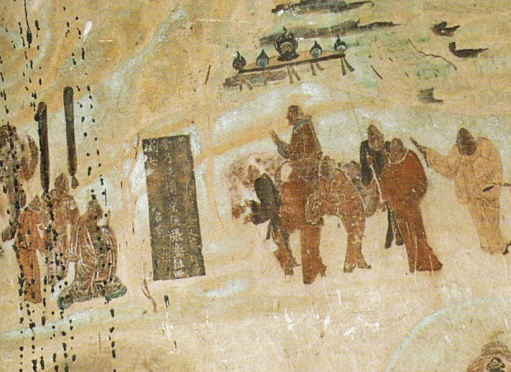
Trade
You need to explore how trade led to the development of permanent settlements and changed relationships between competing societies

Ask yourself these questions about how trade impacted the society you have chosen.

- Who did they trade with (i.e. other civilizations or cultures)?
- What goods did they trade (i.e. foods, previous stones, silk etc.)?
- What materials or goods was your chosen civilisation rich in?
- How did trade enrich and empower your chosen civilisation?

Your presentation will be done as a group. Choose your partners carefully!

Your presentation will be graded using Criteria A, C and D.

