Welcome

Early Years K2 2017-18

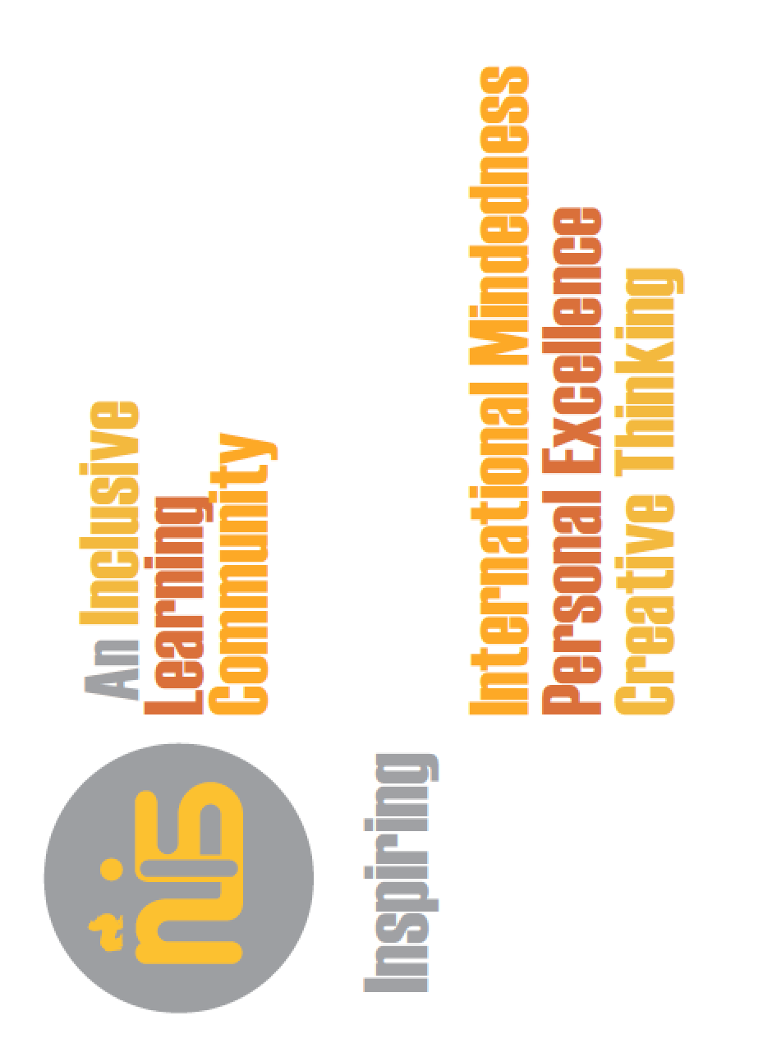
Class of 2030

Snacks and Lunch
A fruit snack is provided by the school.

Snack from home: please send healthy snacks in labeled containers. Note that we are a nut-free school.

Drink: please send in a labeled water bottle

Lunch: choice of school lunch or home lunch. Lunch will be eaten in the Cafeteria.
Outdoor Play Everyday
“There is no such thing as bad weather,
only inappropriate clothing.”
– Sir Ranulph Fiennes
In order to offer this opportunity to our students, we need your help.
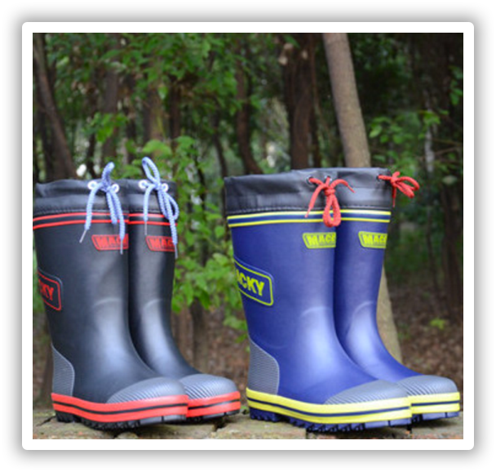
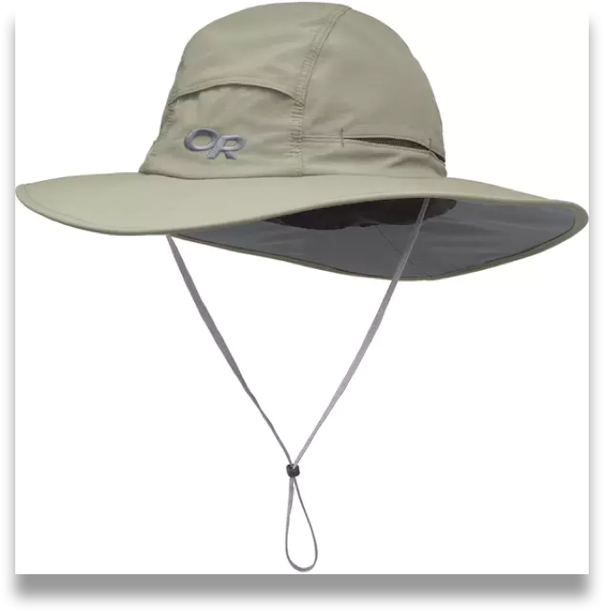
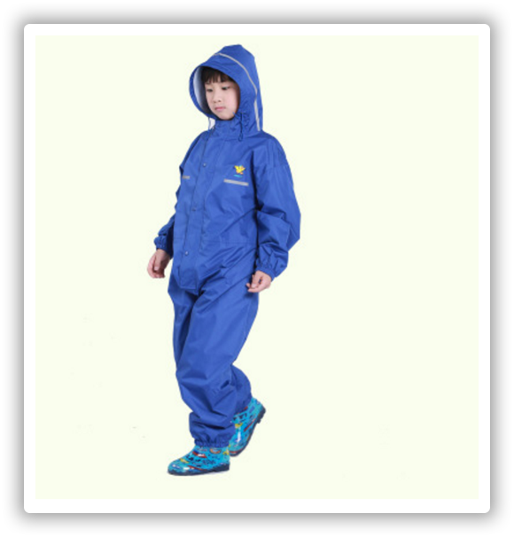
Your child will need these items labeled and kept at school all year:

Sun hat
Rain boots
Rain suit

“In play, the child is always behaving beyond his age, above his usual everyday behavior. In play, he is, as it were, a head above himself.”

-Lev Vygotsky

Early Years supplies

To help set your child up for self-management success in the Early Years in August, please make sure that he/she has the following supplies, labeled with his/her name, at the beginning of the school year:

- 1 backpack - measuring approximately 35 cm wide x 40 cm tall x 15 cm deep. While the small child-size backpacks are cute, they are not functional for EY students.

- 2 swim kits in separate bags - each bag containing a pair of goggles, swim suit, towel, and a latex or rubber swim cap. You should send the two kits at the beginning of the year. Your child will cycle through the kits in order to ensure there is always a kit ready to go. They will be returned home for washing the day they are used.

- 1 pair of snow boots, lightweight jacket or sweater – students will be active outdoors throughout the school year. In order to stay warm and dry during the changing seasons, the students should wear snow boots on winter days. An extra lightweight jacket or sweater should be left in school.

- 2 complete season-appropriate outfits - (tops, pants, socks, underwear), packaged in a plastic bag, to be left at school.

- 1 water bottle - which will go home each day and be returned each morning. It is imperative that your child comes to school in sports shoes because your child will have either PE or Music and Movement each day. If your child can tie his or her own shoes, laces are fine. If not, please equip them with no-tie sport shoes.

Thank you for supporting your child’s education.
We look forward to sharing your child’s learning journey next year.

The NIS Early Years Team

