The Cuban Missile Crisis

Source Investigation

Background Information:
The Cuban Missile Crisis took place in 1962. It lasted 13 days. It began when US spy planes flying over Cuba took reconnaissance photographs which showed nuclear missile installations being built, some almost complete. Further intelligence revealed USSR warships heading towards Cuba carrying nuclear missiles probably for the new sites. President Kennedy had three options; do nothing, attack the Soviet ships or create a naval blockade around Cuba. The Soviet Premier was Khrushchev.
The island of Cuba is close to Florida and in 1962 was controlled by a communist government led by Fidel Castro.

Look at the sources below. You will carry out an investigation into their reliability and decide why this was such a significant turning point in the Cold War.

Source A:
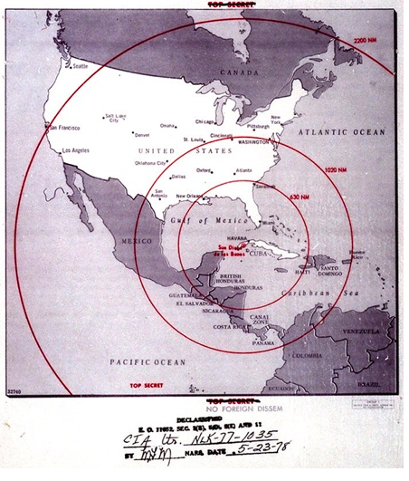
Map of the western hemisphere showing the full range of the nuclear missiles under construction in Cuba, used during the US government secret meetings on the Cuban Missile Crisis and created by the CIA.
Date:October, 1962

Source B:
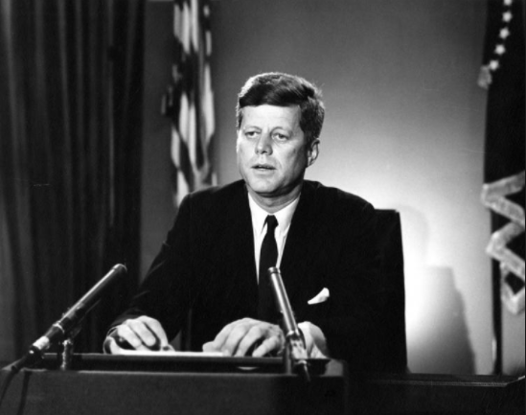
Photograph of John F Kennedy addressing the nation on live TV in October 1962 at the time of the Cuban Missile Crisis taken in the White House.

Source C:
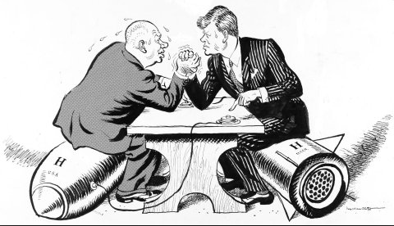
This British cartoon of 29 October 1962 shows Kennedy and Khrushchev arm-wrestling for power, sitting on nuclear weapons. The caption read: 'OK Mr president, let's talk'
Source D:
On October 24th 1962 a group of Soviet ships reached the American blockade. One oil tanker was allowed to pass through without being searched. The other ships turned back. President Kennedy’s brother Robert said that in the eyeball to eyeball confrontation ‘Khrushchev just blinked’. Nuclear warfare had been avoided.

Extract from a school textbook published in 1995.

Source E:
We sent the Americans a note saying that we agreed to remove our missiles and bombers on condition that the President gave us assurances that there would be no invasion of Cuba. Finally, Kennedy gave in to us and agreed to make a statement giving us such an assurance. It was a great victory for us, a spectacular success without having to fire a single shot.

Extract from Khrushchev’s memoirs written in the late 1960s.

Source F:
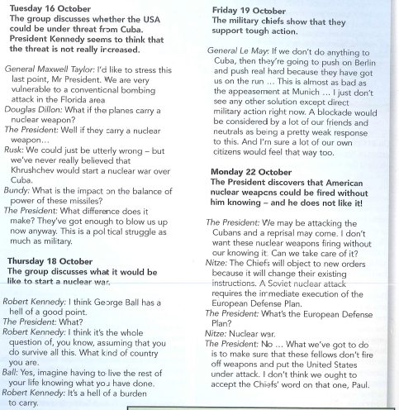

Kennedy and his political advisors met for 13 days and Nights from 16th October. Unknown to many of the advisors Kennedy taped the discussions that took place about how to react to the situation. Source C is from a transcript of these tapes.

