Hongwu: The emperor who lived in Nanjing

Task: You have been working for Scholastic Inc as an author who writes autobiographies of famous people for children in PYP. Your editor-in-chief has asked you to write a biography on the life and times of Hongwu, the first emperor of the Ming Dynasty in China.

Your book needs to have chapters and the chapter headings are:

- His early life-when he was born, what he did, his family
- Coming to power-how and why did he come to power
- Being in power-some changes that he made when in power
- Death-when he dies and who took over

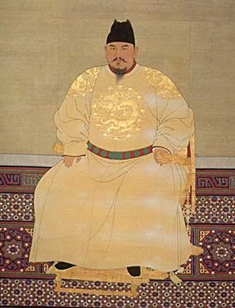
Remember that this book is for PYP students (grade 4 and 5) so it must be easy to read and you need to have pictures illustrating the information that you have written (think about the Ancient Greek books we used for research when doing the Olympic books).

Format of your book:

- Front cover: which includes title of the book and pictures (you want to get the readers attention, so make it interesting).
- Table of contents: this will show the different chapters of your story
- Chapter headings and information
- Pictures that go with each chapter
- Bibliography of the sources that you used
- Back cover explaining what information is in your book

You will be graded on criterion A,B,C and D.

