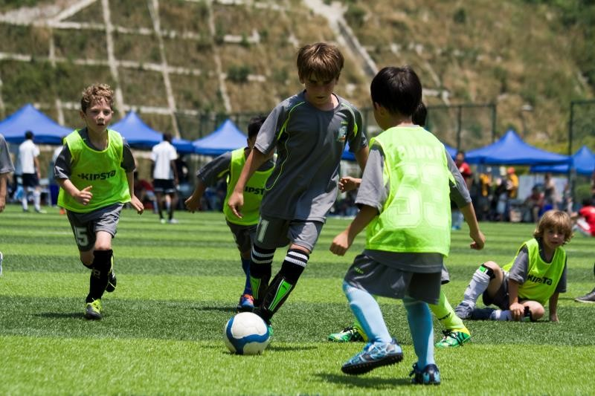
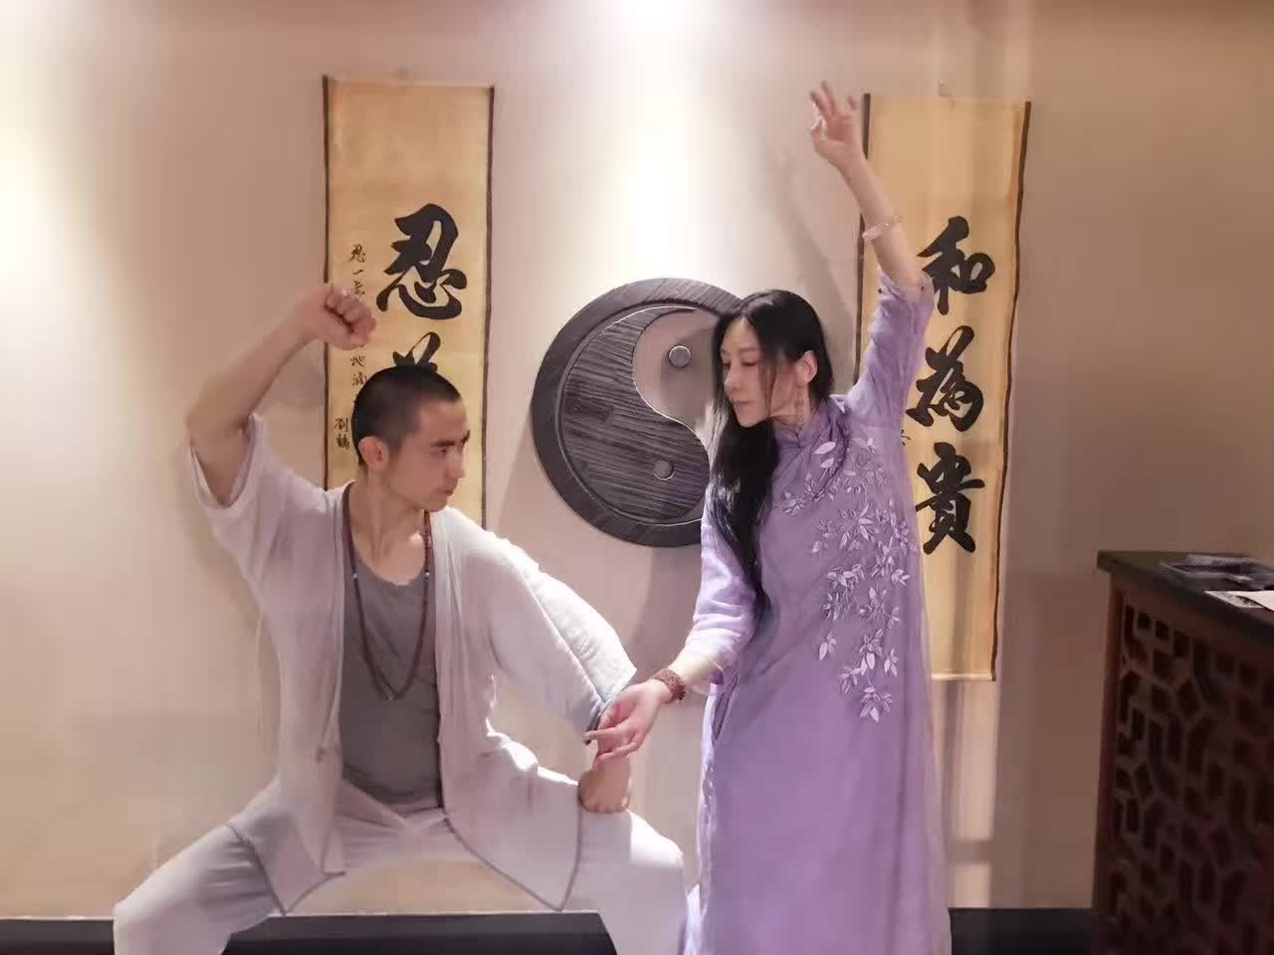
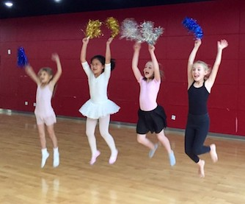
Important Community Activities Cancellation Information

Community Activities

On September 23rd, as well as from September 25th to September 30th, 2017.
There will be no Ballet, Taekwondo, Jiu Jitsu, Oil Painting for kids and Hip Hop on Saturday, September 23^{rd.}
Basketball and CrossFit will run as usual on September 23rd.
Next week, Community Activities will be suspended from Monday, September 25th until Saturday, September 30th due to the Accreditation Team visit.
Basketball for adults, Badminton, Golden Balls and Volleyball will run as usual.
The usual Community Activities schedule will resume after October holidays, on Wednesday, October 11th.
If you haven’t paid for your activity yet, please come to my office to pick up your payment slips. Office hours are Tuesday 8:00 to 14:30, Thursday and Friday 8:00 to 10:00. Thank you for your cooperation.
Myroslava Kuntner cac@nanjing-school.com

