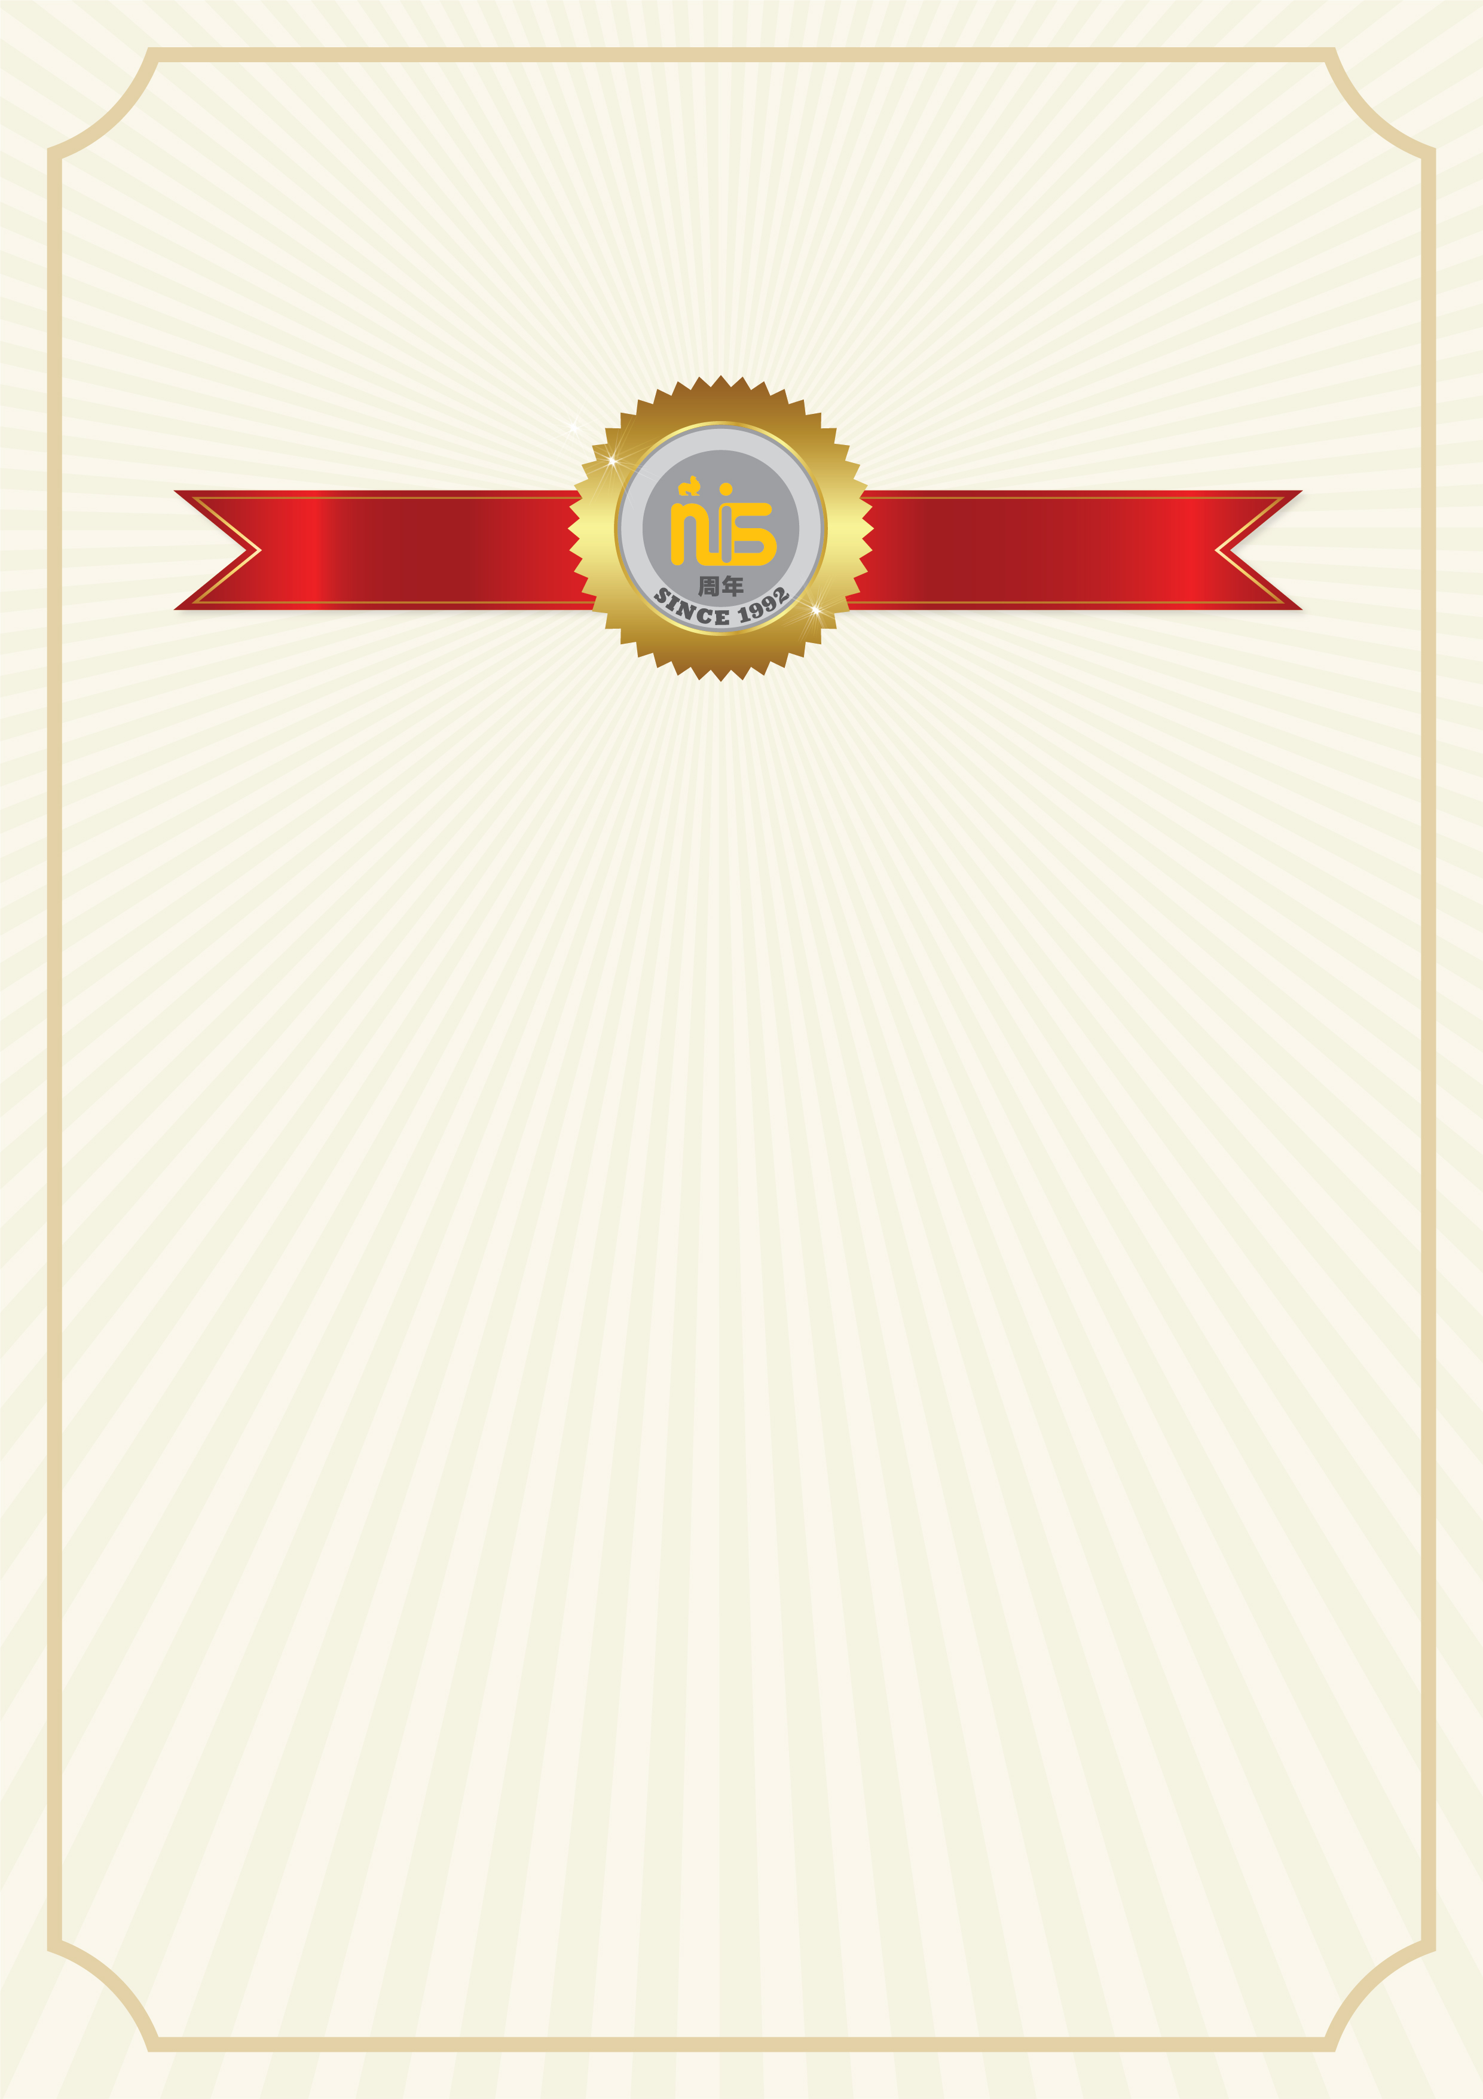

Middle and Upper School
Awards Assembly

June 17, 2020 2pm Online

Our Semester Two Awards Ceremony will recognise outstanding student achievement in academics. The list of awards recipients will be posted on the MS/US large group room window. Students will be aware of the awards they may be receiving. Parents are welcome to attend this event via Microsoft Teams. A link to the event will be sent through email the day before the Awards Assembly will take place.
Katie Ham
Head of Upper School
katieham@nanjing-school.com
Ruth Clarke
Head of Middle School
ruthclarke@nanjing-school.com

