Actuality (n) — The voices in a story that are not the reporter’s/narrator’s. Usually recorded on-location or in a studio interview. Also known as “acts,” “cuts,” or “sound bites.”

Ambience (n) — The pervasive sound at a location. (E.g. Traffic on a road. Doors slamming. Sounds of a demonstration. Birds and wind in a forest.) Can be used as an actuality itself or mixed under narration or other actualities. Also known as “ambi” or “nat sound” or less commonly as “sfx.” [Though, to be clear, ambience is not “sound effects”! It is real sound, not faked.]

Backtime (v) — To determine where to start playing an audio element so that it posts or ends at a specified time. Often used for deadrolls. (See “post” and “deadroll” definitions below).

Deadroll (n) — Sound or music that begins inaudibly at a specific time in a mix – so that it will come to its natural end at a specific time.

Fade (in, out, up, down, under) (v) — To adjust the volume of sound from low to high or high to low at a gradual pace.

Fade to black/Fade away (v) — To decrease the volume of a sound until it is inaudible — while still in the clear.

Mask (v) — To use existing ambient sound to cover over bad edits or to smooth transitions.

Montage (n) — (At right) Several pieces of audio combined sequentially to create a single sound element.

Room tone (n) — Indoor ambience recorded at the place where an interview is conducted or an event takes place. Usually low dynamic level.

Sweep (v or n) — To quickly fade up; a quick fade up.

Synch up (v) — To combine two or more pieces of audio so that they line up exactly. Usually done with audio that matches (for example, a tape sync).

Two-way (n; can also be used as a verb) — An on-air conversation between two people, usually a host and an interviewee. Common term used to describe conversations heard on newsmagazines. (A “three-way” is a host and two guests … and so on.)

Track/Voice Track (n) — The reporter’s narrative, read from their script.

Voicer (n) — A news spot involving only the reporter’s voice — no actualities.

Wrap (n) — A news spot featuring an actuality placed between the reporter’s tracks (the actuality is “wrapped” by the tracks).
Criteria A
- explains the need for a solution to a problem for a specified client/target audience | - Write an Introduction to the topic: Sound Design/Foley Art  - What is Sound Design?  - What is Foley art?  - What are audio books?  - Why are their audio books?  - What are the benefits of digital audio books?
- constructs a research plan, which identifies and prioritizes primary and secondary research needed to develop a solution to the problem, with some guidance | Interviewing grade 1 students  Finding books to create
- analyses a range of existing products that inspire a solution to the problem | Find audio books on you tube. Are there sound FX? Is there a narrator? Is the audio clear?
- develops a design brief, which explains the analysis of relevant research. | Design Brief that explains what is needed to create a audio book.

Answer these 2 questions. Provide the source/s where you found the information.

What is Sound Design?

What is Foley Art?

List of sounds and how they’re made with Foley:
Sound | How it’s made | Where you found it.

Horses Running | Coconut shells, Plungers stuffed with clothes, tapped. | “The Magic of Sound” https://www.youtube.com/watch?v=UO3N_PRIgX0

Questions for Grade 1 Students:
Think of 3 questions that will help you answer what book a grade 1 student would like to hear read to them… Remember to keep it simple.

Books I chose:
Book I chose… | Reason I chose it…

Analyzing products: (3)
Link to audio picture book:

“The Rainbow Fish”
https://www.youtube.com/watch?v=h6S4IPMs5ZY&list=PLOUqZ7AWe_vRvP2SRmAgq7Xj9eLAYrdON

This book shows some of the page (only the image, not words) and the narrator reads the book. When more then one character speaks the narrator changes their voice or there is another person reading.

Design Brief:

What are you creating for this unit? Why?

What do you need in order to create an audio book?

Criteria B

- develops a design specification which outlines the success criteria for the design of a solution based on the data collected | Specifications:  Can be published to YouTube or other streaming sites. (.mov or .mp4)  Fits in a 16:9 aspect ratio  Use Foley art to create a specified # of sound FX per page. All pages need at least 1 SFX.  Record audio in high quality.  Answer for your spec’s:  What will make your Foley successful?
- presents a range of feasible design ideas, using an appropriate medium(s) and annotation, which can be correctly interpreted by others  - presents the chosen design and outlines the reasons for its selection with reference to the design specification | Create a table.  ii.  On one side of the table put images of the pages in your book.  On the other side of the table record the types of sounds that need to be recorded for that page.  iii.  For each sound – come up with a few ideas for how to create that sound using Foley.  Create another table. On one side put the sound you need to create. On the other side but your tested ideas for how to create it. Once tested select the one that is best for your project.
develops accurate planning drawings/diagrams and outlines requirements for the creation of the chosen solution. | For at least 5 different sounds, create a tutorial for how to produce each sound using Foley.

Design Specifications:

- Every page needs at least 3 sound FX.
- Sound FX must be recorded in High Quality and saved as a .WAV file.
- Must mix Audio of Voice with Sound FX.
- Must add the matching visual page in the book with the audio
- Final product must be an HD video of the entire book. 1920x1080 with high quality audio

ii. example – the whole book!!!!
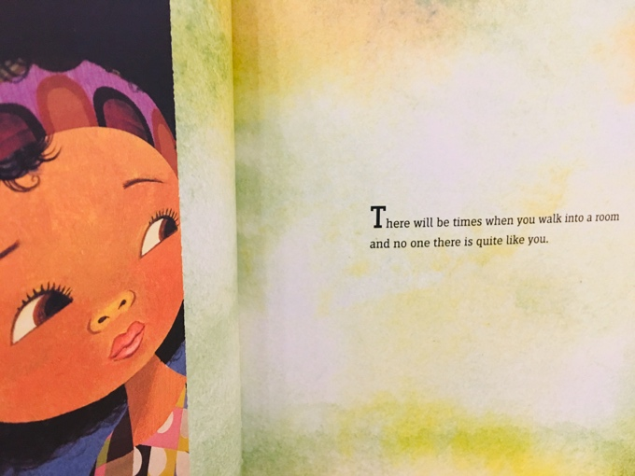 | Sounds needed:  - Footsteps  - Door Opening  - Wind/Breeze  Voice Over

- example | Ideas + Test results:
Footsteps | Idea 1: Using shoes and sand. Record myself walking in the sand on the floor.  Idea 2: Using shoes on my hand record the shoes on the table, moving them with my hands.  Justification for choice: After testing I thought Idea 2 was a more realistic sound. I made a slight change and used shoes with heals instead of sneakers.
Clock | Idea: tapping the table  Ideas 2: tapping something metal like scissors

Criteria C:
Record all of your Audio Files:

Sound FX | Recorded Audio File:
Footsteps | Test 1: Idea 1: https://nanjingschool-my.sharepoint.com/:u:/g/personal/nikmadalinski_nanjing-school_com/EQBd5z4x3ZNPseXLPGSV6BsBOpITYlHB8BaEfu2lP8dzAQ?e=ijOxFa

Link to mixed Audio File with Voice Over:

Link to Final Product:

